

NAME: Manan Verma SEMESTER: 4th
SECTION: 24_AIT_KRG-G1 UID: 24BAI70008
SUBJECT CODE: 24CSH-298
FACULTY’S NAME: Mr .SHALABH BHATIA

Experiment 4

AIM:
To design and implement PL/SQL programs utilizing conditional control statements such as IF–ELSE, ELSIF, ELSIF ladder, and CASE constructs in order to control the flow of execution based on logical conditions and to analyze decision-making capabilities in PL/SQL blocks.

Software Requirements:
- Database Management System:
  - PostgreSQL
- Database Administration Tool:
  - pgAdmin

Objective:
Implement control structures in PL/SQL (IF-ELSE, ELSE-IF, ELSE-IF LADDER, CASE STATEMENTS in PL-SQL BLOCK)

Problem Statement
Develop and execute PL/SQL programs that demonstrate the use of conditional control statements. The programs should employ IF–ELSE, ELSIF, ELSIF ladder, and CASE statements to evaluate given conditions and control the flow of execution accordingly, thereby illustrating decision-making capabilities in PL/SQL blocks.

Table Creation:
CREATE TABLE student_lab (
student_id SERIAL PRIMARY KEY,
student_name VARCHAR(50),
marks INTEGER,
day_no INTEGER
);

INSERT INTO student_lab (student_name, marks, day_no) VALUES
('Manan', 95, 1),
('Aarav', 78, 3),
('Simran', 62, 5),
('Kunal', 45, 7),
('Neha', -5, 9);

1. Problem Statement – IF–ELSE Statement
Write a PL/SQL program to check whether a given number is positive or non-positive using the IF–ELSE conditional control statement and display an appropriate message.

Code:
DO $$
DECLARE
r RECORD;
BEGIN
FOR r IN SELECT * FROM student_lab LOOP
IF r.marks > 0 THEN
RAISE NOTICE '% has POSITIVE marks (%).', r.student_name, r.marks;
ELSE
RAISE NOTICE '% has NON-POSITIVE marks (%).', r.student_name, r.marks;
END IF;
END LOOP;
END $$;

Output:

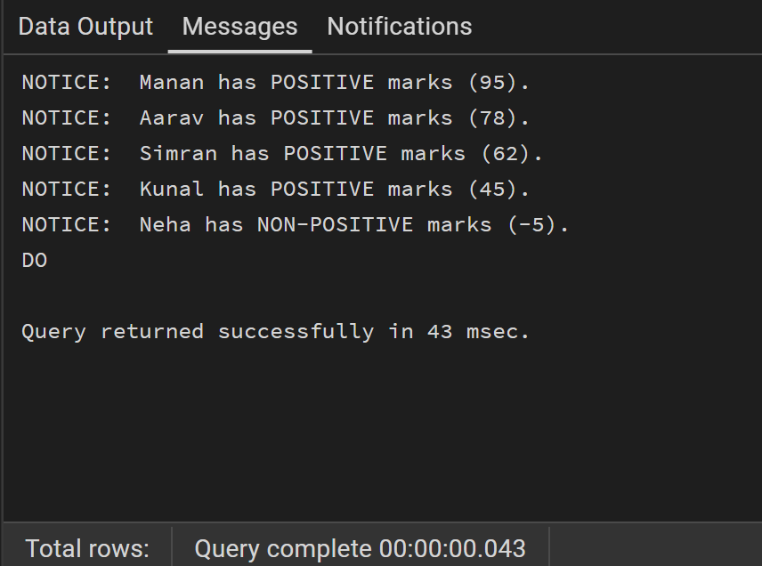

2. Problem Statement – IF–ELSIF–ELSE Statement
Write a PL/SQL program to evaluate the grade of a student based on the obtained marks using the IF–ELSIF–ELSE statement and display the corresponding grade.

Code:
DO $$
DECLARE
r RECORD;
BEGIN
FOR r IN SELECT * FROM student_lab LOOP
IF r.marks >= 90 THEN
RAISE NOTICE '% : Grade A', r.student_name;
ELSIF r.marks >= 75 THEN
RAISE NOTICE '% : Grade B', r.student_name;
ELSIF r.marks >= 60 THEN
RAISE NOTICE '% : Grade C', r.student_name;
ELSE
RAISE NOTICE '% : Grade F', r.student_name;
END IF;
END LOOP;
END $$;

Output:

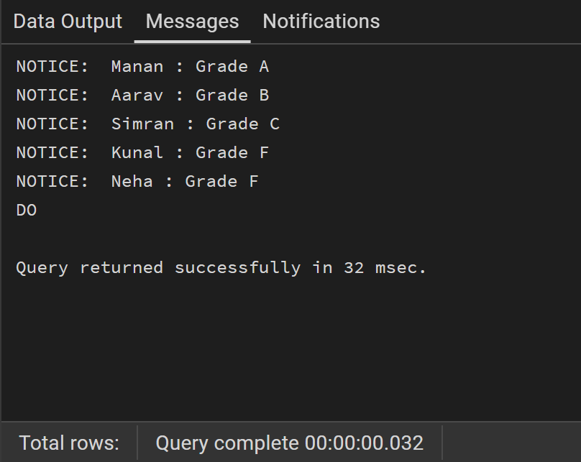

3. Problem Statement – ELSIF Ladder
Write a PL/SQL program to determine the performance status of a student based on marks using an ELSIF ladder and display the appropriate result.

Code:
DO $$
DECLARE
r RECORD;
BEGIN
FOR r IN SELECT * FROM student_lab LOOP
IF r.marks >= 90 THEN
RAISE NOTICE '% : EXCELLENT', r.student_name;
ELSIF r.marks >= 75 THEN
RAISE NOTICE '% : VERY GOOD', r.student_name;
ELSIF r.marks >= 60 THEN
RAISE NOTICE '% : GOOD', r.student_name;
ELSIF r.marks >= 50 THEN
RAISE NOTICE '% : AVERAGE', r.student_name;
ELSE
RAISE NOTICE '% : POOR', r.student_name;
END IF;
END LOOP;
END $$;

Output:
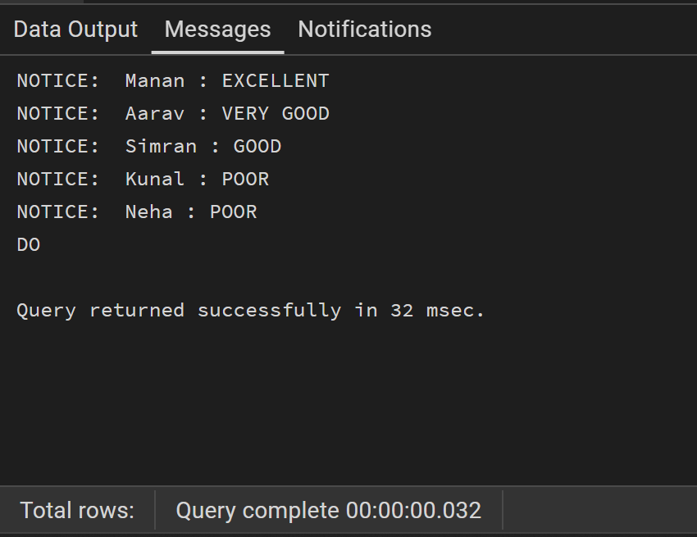

4. Problem Statement – CASE Statement

Code:
DO $$
DECLARE
r RECORD;
day_name TEXT;
BEGIN
FOR r IN SELECT * FROM student_lab LOOP
day_name := CASE r.day_no
WHEN 1 THEN 'Monday'
WHEN 2 THEN 'Tuesday'
WHEN 3 THEN 'Wednesday'
WHEN 4 THEN 'Thursday'
WHEN 5 THEN 'Friday'
WHEN 6 THEN 'Saturday'
WHEN 7 THEN 'Sunday'
ELSE 'INVALID DAY'
END;

RAISE NOTICE '% : Day % is %', r.student_name, r.day_no, day_name;
END LOOP;
END $$;

Output:

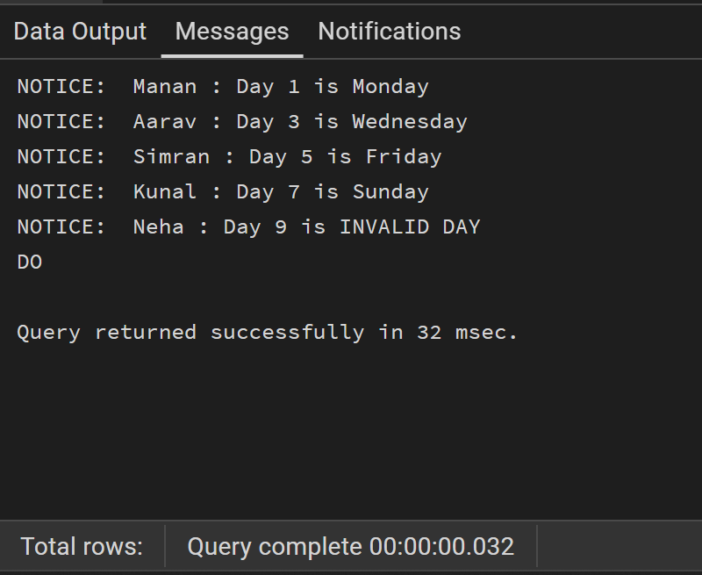

Learning Outcomes:
After completing this experiment, the student is able to:
- Understand conditional control statements in PL/pgSQL.
- Implement IF–ELSE and IF–ELSIF–ELSE statements.
- Apply ELSIF ladder for evaluating multiple conditions.
- Use CASE statements for selection-based execution.
- Control the flow of execution in PL/pgSQL blocks.
- Execute and analyze procedural SQL programs in PostgreSQL.

